Topic of Assignment | Difference Between SSD and HDD
Name | Remsha
Registration No. | CS120252046
Program | BS Computer Science
Semester | 3rd Semester
Submitted To | Mohammad Zeeshan
Date | 20 September 2026

Introduction
As we know, every computer needs a place to save data like files, photos, software and the operating system. This place is called storage. In computers, mostly two types of storage are used, which are HDD (Hard Disk Drive) and SSD (Solid State Drive). Both of them are used to save data but they work in a different way.
An SSD has no moving parts. It stores data in flash memory using electricity. Because of this, SSDs and HDDs are different in speed, noise, price, power use, and lifespan.

Difference between SSD and HDD
The table below shows the main differences between the two. The values are average, so they can vary depending on the company and model.
No. | Parameter | HDD (Hard Disk Drive) | SSD (Solid State Drive)
1 | Working | Data is stored on magnetic disks which rotate inside the drive. | Data is stored in flash memory chips. There is no disk in it.
2 | Moving parts | Yes. The disk, motor and read/write arm all move. | No, nothing moves inside it.
3 | Speed | Around 80 to 160 MB/s. | SATA SSD gives around 500 MB/s.  NVMe SSD gives 3,000 MB/s or even more (up to 7,000).
4 | Access time | 5 to 10 ms, because the arm has to reach the correct place and the disk also has to rotate. | 0.05 to 0.1 ms, which is much less than HDD.
5 | Boot time | Slower | Faster
6 | Price | Cheaper. | Expensive.
7 | Durability | Less durable | More durable
8 | Noise | Produce noise | Silent.
9 | Heat | Produce more heat | Produce less heat
10 | Physical size | Larger and heavier | Lighter and smaller
11 | Life | Usually lasts for 3 to 5 years but with proper care works for 5 to 10 years | Cells can be written only a limited number of times (TBW), but a normal user does not reach this limit easily.
12 | Data recovery | Data recovery is easy | Data recovery is difficult.
13 | Without power | Data can be save for many years | If it is kept without power for a very long time, data may get lost.
14 | Best use | Best for storing a lot of files , movies , photos and backups | Operating system, games, video editing, laptops and fast servers.

Working of HDD
HDD is the old type of storage. Inside it there are round metal disks which are called platters, and a magnetic layer is coated on them. A motor keeps rotating these platters all the time, normally at 5,400 or 7,200 rpm. There is also an arm inside the drive called the actuator arm, and at the end of this arm there is a read/write head. The head stays very near to the platter but it does not touch it. It reads and writes the data by using the magnetic signals on the disk.
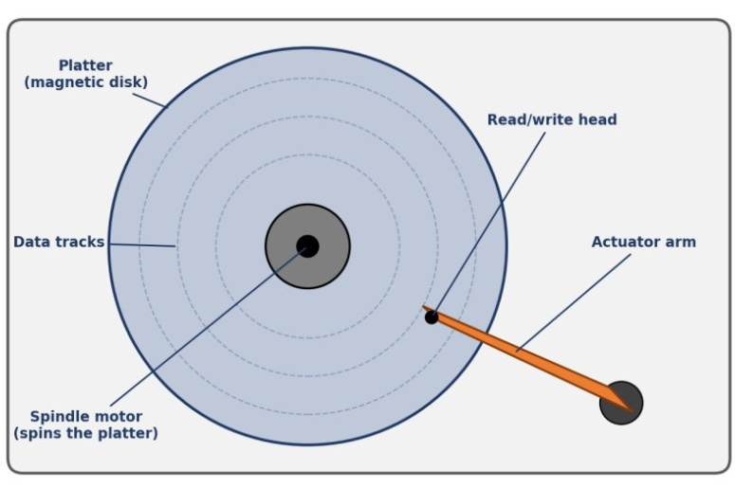
Fig 1: Parts of a hard disk drive
The main parts of HDD are:
- Platter: the disk on which the data is saved.
- Spindle motor: it rotates the platters.
- Actuator arm and head: the arm moves over the platter and the head reads or writes the data.
- Tracks and sectors: the data on the disk is saved in circles (tracks) which are divided into small parts (sectors).

Working of SSD
SSD is the new type of storage and it does not have any moving part. It saves data in NAND flash memory chips and the data stays saved even if the power is off. There is also a small chip in it called the controller, which works like the brain of the SSD. It decides where the data will be saved and it also makes sure that all the memory cells are used equally so that any one cell does not get damaged early. Many SSDs also have a small DRAM cache.
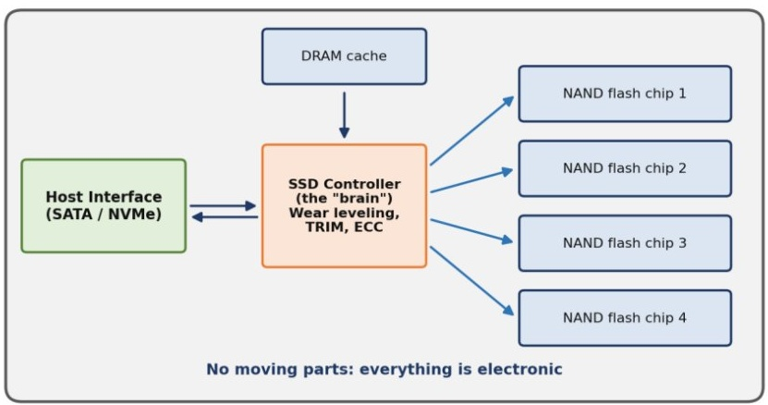
Fig 2: Block diagram of an SSD
Some terms which are used for SSD:
- NAND flash: the memory chips in which data is saved.
- Controller: the chip which controls the whole SSD.
- Wear leveling: it spreads the writing on all cells equally so the SSD works for a longer time.
- TRIM: it tells the SSD which data is deleted so it can clean that space and stay fast.
- NVMe: a new and faster way to connect the SSD with the computer. It is much faster than SATA.

Flowchart of reading a file
This flowchart shows what happens when we open a file in HDD and SSD. First and last steps are almost same in both. The main difference is in the middle. In HDD the arm has to move and the disk has to rotate to the correct place, but in SSD just an electric signal is sent so it is much faster.
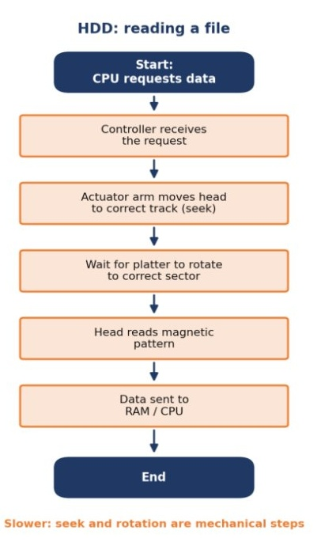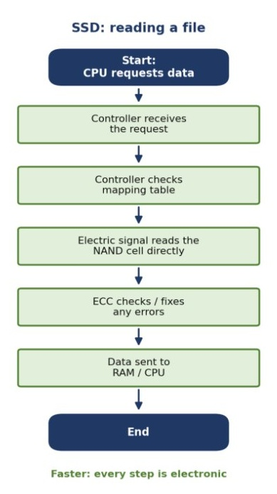
FFlowchart of reading a file in HDD and SSD

Choose HDD or SDD ?
This flowchart shows that what we choose according to our needs
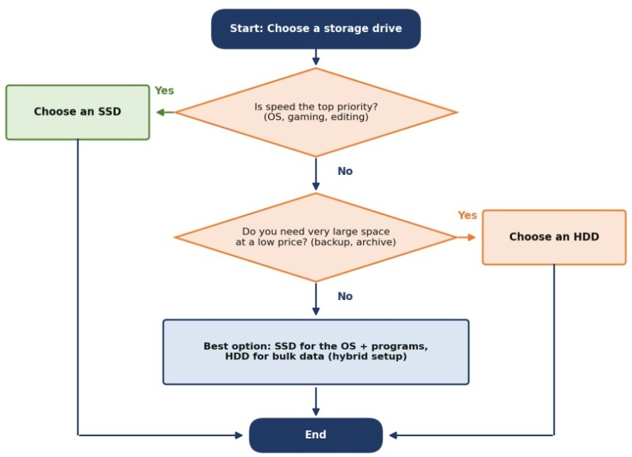

 | Advantages | Disadvantages
HDD | Cheap, big sizes available, data can be recovered easily, good for keeping old data. | It is very slow , produce noise , uses more power .
SSD | Very fast, no noise, uses less power, safe from shocks, computer starts quickly. | Very expensive , data recovery is difficult

Conclusion
Both SSD and HDDs are usefull in their own terms . SSD is very fast use less power and starts computer quickly but on the other hand HDD is cheap , data can be recovered easily and good for keeping data.Users can choose according to their budget , requirements and storage needs .

